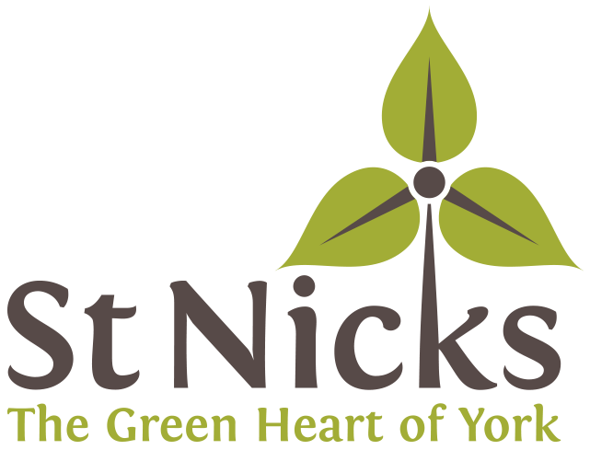

Recruitment Pack and Application Form

**Trustee**

**Board of Trustees**

FRIENDS OF ST NICHOLAS FIELDS

October 2024

|  |  |
| --- | --- |
|  |  |
|  |  |

**An introduction from the Chair.**

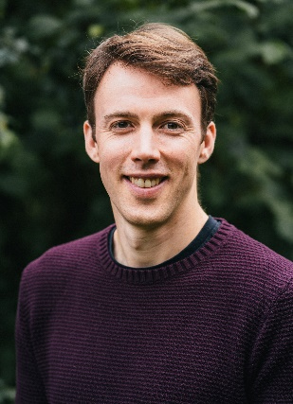

Thank you for your interest in this role!

We are looking for enthusiastic individuals to join our Board as a new Trustee. We are a small, but high-impact charity with a friendly and dedicated team of staff, Trustees and volunteers. We are at an exciting stage of our journey, having recently undergone a period of rapid growth, and a recently appointed new CEO. We are looking to update our Environment Centre located on our 24 acre nature reserve in York. This year sees the 20th anniversary of our building’s original construction and we need to both improve and adapt the space to suit our needs as well as update it in terms of the latest technology in relation to retrofitting and sustainability.

Our trustee board is made up of individuals with a wide range of skills and experience. Although we are recruiting broadly to our trustee board, we would welcome applications from individuals with skills and experience in IT systems and digital.

This pack contains key information about us and the role of Trustee at St Nicks. Please don’t hesitate to get in touch with me if you have further questions or would like to have an informal chat.

Kind regards – Stuart Leslie (Chair of Trustees)

**About St Nicks**

St Nicks is the green heart of York: a centre for nature and green living, with an ambitious vision to enable thriving and connected biodiverse communities. The charity started as ‘Friends of St Nicholas Fields’ in the 1990s by transforming a former landfill site into a thriving Local Nature Reserve. Over the years, our size and ambition has grown, and we have become an established and valued part of our city community.

Our current mission is to build and connect flourishing communities through greenspace regeneration, nature-based wellbeing and sustainable living. These activities are underpinned by our values of collaboration, integrity, innovation and professionalism, and focus on three core strategic aims:

* “Nature” - greenspace regeneration
* “People” - improving wellbeing through nature connectedness
* “Planet” - empowering communities to flourish sustainably

We have a passionate team of staff, Trustees and volunteers who run a range of projects, events and services with the help of our partners and supporter to help us achieve these aims.

We are partially funded by City of York Council and partly by grants from other sources. The rest of our income comes from membership, donations, fundraising events and other activities.

**The Board of Trustees**

We have an engaged board of trustees with a broad skillset. Our trustees play an important role in shaping the direction of our charity as well as holding overall legal and financial responsibility for the whole charity, overseeing our work and ensuring we are meeting our charitable objectives. We also encourage trustees to join in social events with our staff and broader community and volunteers.

**Our Commitment to Quality & Diversity**

We are fully committed to making sure that our services, special places and the support we offer are as **welcoming**, **inclusive** and **accessible** as possible.

We want St Nicks to reflect a **diverse** society where we learn from each other and build a healthy respect for each other, both so that we can thrive together today and so that we can live together as sustainably as possible in the future.

We will strive to ensure that people of **all backgrounds and characteristics** are able to fully gain from and contribute to St Nicks, and we are committed to listening to everyone in our community to make sure that this is the case, identifying and addressing issues as they arise.

In seeking new trustees we are keen to build a diverse team with different skills and talents to help the charity continue in its journey of growth and evolution.

St Nicks is committed to equality, diversity and inclusion in our recruitment process and elsewhere and we encourage applications from a diverse range of people including those with disabilities, those from Black and Asian and minority ethnic groups, those from the LGBTQ+ community and those from disadvantaged or non-traditional backgrounds.

Please do not be put off from applying if you have never been a Trustee before. The most important qualities for our Trustees are enthusiasm, engagement and a desire to get involved and make a contribution to St Nicks’ work. If you do become a trustee, we can and will support you while you learn about what the role involves.

**Next steps**

Please read the Trustee role description below then complete and return the very short application form in this pack.

Please do have a look at our website [stnicks.org.uk](https://stnicks.org.uk/) to find out more about us, or email Stuart Leslie on [chair@stnicks.org.uk](mailto:chair@stnicks.org.uk) if you have questions, or would like more information.

Please contact us on [info@stnicks.org.uk](mailto:chiefexec@stnicks.org.uk) if you would like an audio or a large print application form, if you have other accessibility needs or if you would like help with applying.

**What do trustees do?**

The Trustee role at St Nicks is a voluntary (unpaid) position. It provides an opportunity to give something back to the local community and use your skills and experience to make a meaningful difference to the environment and the lives of others.

The role of our Trustees is to:

* Hold collective overall legal and financial responsibility for St Nicks
* Ensure that we deliver on our strategic and business plans, achieve financial sustainability and manage our organisation’s performance;
* Ensure that St Nicks complies with its governing document (its Articles of Association), charity law, company law and any other relevant legislation or regulations;
* Ensure that St Nicks pursues its objects as defined in its governing document;
* Ensure that St Nicks applies its resources exclusively in pursuance of its objects ;
* Contribute actively to the Board of Trustees by giving firm strategic direction to St Nicks;
* Set overall policy, defining goals, setting targets, and evaluating performance against agreed targets;
* Ensure the financial stability of St Nicks.

**What would that mean for you?**

Trustees are expected to attend our Management Committee meetings every two months. These are friendly and informal sessions, at which trustees review what has happened since the last meeting, hear from the Chief Executive and take any decisions that need to be taken. They are usually held in the evenings between 6- 8pm, but sometimes at 8 – 10am depending on availability of all Trustees.

You would also need to commit approximately 2-3 hours per month to read through papers prior to meetings, read and respond to emails, and attend occasional other sub-committees, working groups or events as required.

If you are selected, we will make sure that you are properly inducted to the Board of Trustees, have a mentor while you are learning about your role and have regular reviews with our Chair.

You will be responsible to the Chair of the Board of Trustees.

**Application for role of Trustee**

Thank you for your interest in the role of Trustee at St Nicks. To help us in the recruitment process we would like to find out a little bit more about you. Please answer the following questions and return your completed application to St Nicks by email on: [chiefexec@stnicks.org.uk](mailto:chiefexec@stnicks.org.uk)

Or by post or by hand to:

St Nicks Environment Centre

Rawdon Avenue

York

YO10 3FW

|  |
| --- |
| **Name**:  **Address**:  **Email**:  **Tel/mobile no**: |

|  |
| --- |
| **Why are you interested in joining St Nicks as a Trustee?** |

|  |
| --- |
| **What experience and expertise would you bring to St Nicks? (Please refer to the role description and specific skill sets described.)** |

|  |
| --- |
| **Do you know of any reason which would prevent you from becoming a charity trustee e.g., undischarged bankruptcy, unspent conviction for deception or dishonesty, or previous disqualification as a charity trustee?**  I declare this information to be true.  **Signed[1]:**  **Date**: |

1. You can type your name here or use a digital signature if you are submitting your application by email.